SOLID DESIGN PRINCIPLES
Monday, September 2, 2024
8:15 AM

a.Single Responsibility Principle
Wednesday, February 26, 2025
8:07 PM
- The Single Responsibility Principle is one of the SOLID principle in Object-Oriented Design.
- It states "A class should have only one reason to change".
- i.e A class should have only one job or responsibility.If a class have multiple responsibilities,change in one area may affect the other ,making the code harder to maintain.

EXAMPLE : VIOLATION OF SRP

- Consider an ECU of a car door module that has 2 main functions
  - Manage door lock state(locked/unlocked)
  - Communicates with CAR n/w
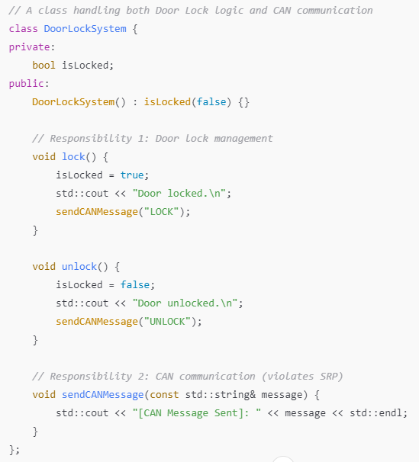
- Here both responsibilities door locking and CAN communication are handled by the same class
- If we need to switch to Ethernet or LIN.The door locking class needs to be modified

APPLYING SINGLE RESPONSIBILITY PRINCIPLE
To fix this we split responsibilities into two classes.
- DoorLockSystem(Handles lock/unlock logic)
- CANCommunicator(Handles CAN message transmission)

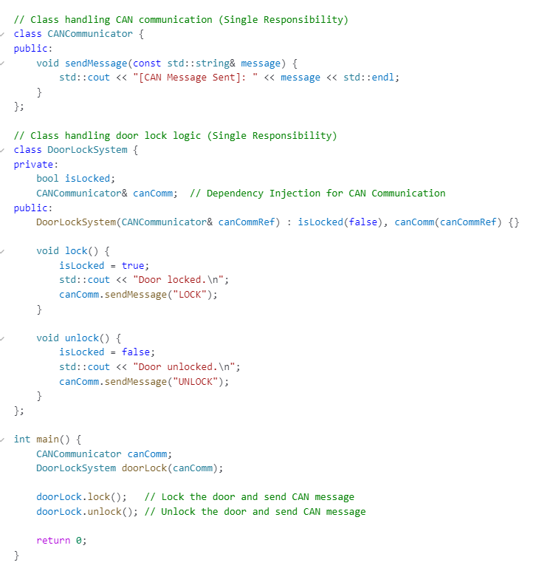
- Here if communication changes (Ethernet/Lin) we need to modify only the CANCommunicator not DoorLockSystem.

b.Open - Closed Principle
Monday, September 2, 2024
8:56 AM
  - The Open-Closed Principle is one of the five SOLID principles in Object Oriented Design.
    - The software entities (classes,modules,functions etc) should be open for extension,but closed for modification.
    - Open for extension :- You should be able to add a new functionality to a class without modifying the existing class.
    - Closed for modification :- Once a class is written and tested,you should'nt need to change its existing code to introduce new behavior.

  - This principle promotes maintainability and scalability by minimizing changes to existing tested code while allowing new features to be added.
  - OCP: VIOLATION
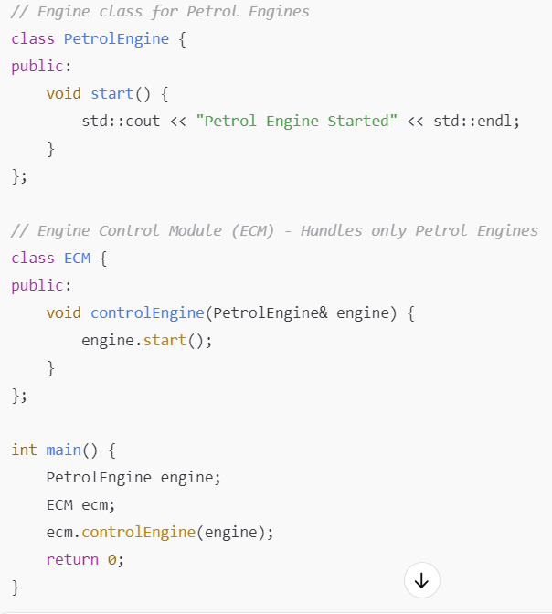
  - If we introduce a DieselEngine or ElectricEngine,we must modify ECM,violating OCP.
  - Everytime a new engine type is introduced,the existing DCM code must be changed and retested.

  - APPLYING OCP
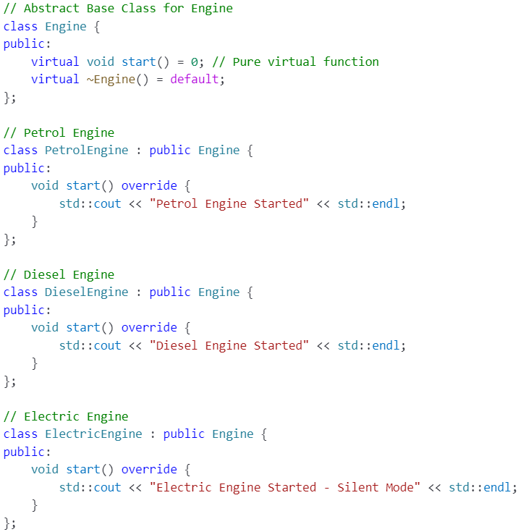

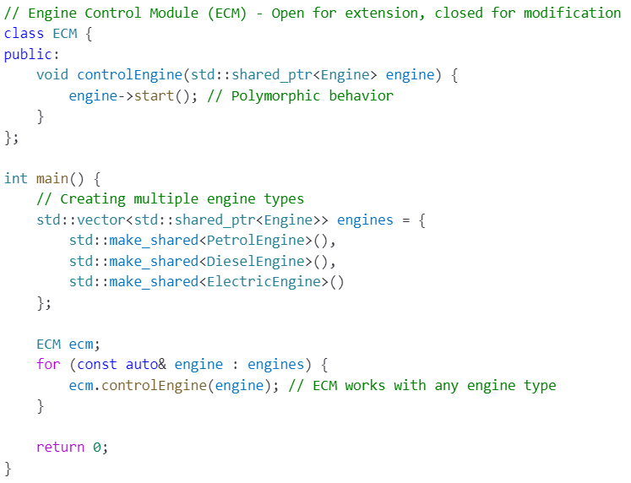

  - Addition of new Engine Types ,does'nt need any modication in the ECM class

c.Liskov Substitution Principle
Tuesday, September 3, 2024
9:59 AM
  - Objects of derived class should be able to replace the object of the base class without affecting the correctness of the program.
  - If a function works with a base class,it should also work with the derived class without any required modifications .
  - VIOLATION OF LISKOV's SUBSTITUTION PRINCIPLE
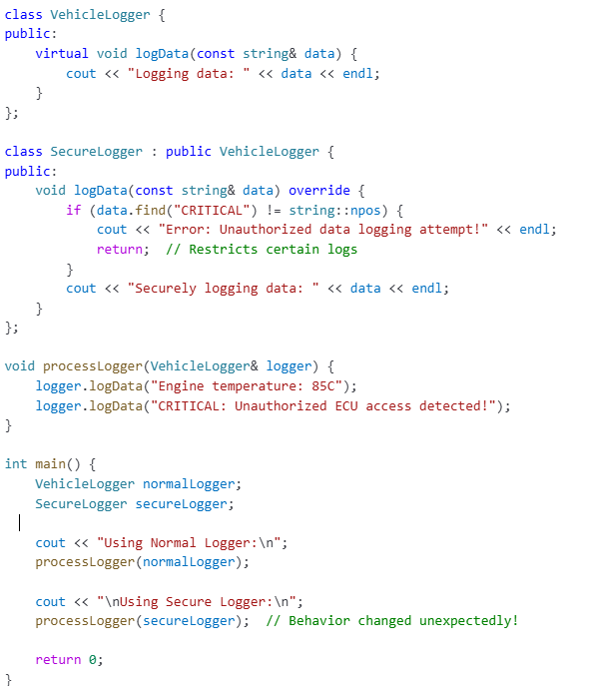
  - Here the base class Vehiclelogger logs the messages while derived class adds additional security restrictions which modifies the expected behavior.
  - Securelogger blocks some logs,which is unexpected because Vehiclelogger assumes all data to be logged.
  - The function processLogger() behaves differently depending on the object type breaking LSP
  - Derived class removes expected Functionality instead of extending it.
  - APPLYING LISKOV's SUBSTITUTION PRINCIPLE
  - Secure Logger is expected to filter logs,it should not derive from vehicle logger,but rather from an independent abstract base class(Ilogger). This ensures that both loggers adher to same expected behavior contract

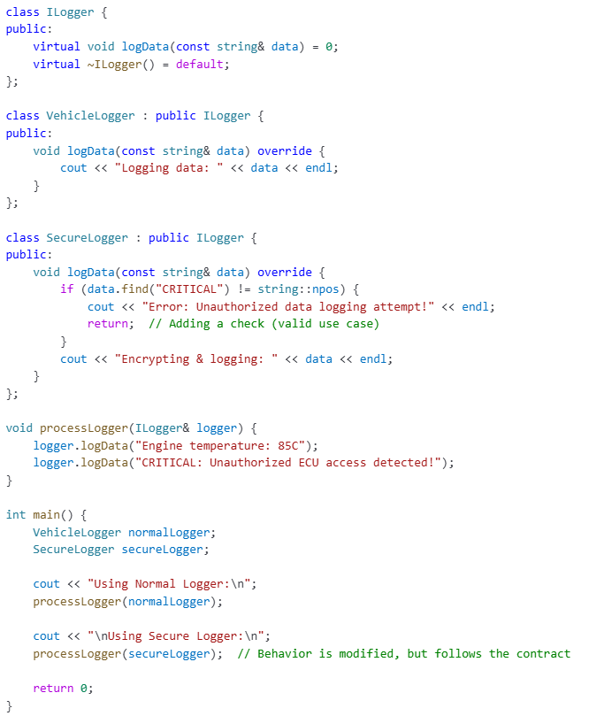

🔹 Why This Follows LSP?
✔ SecureLogger does not inherit from VehicleLogger (which assumes all logs are accepted).
✔ Both VehicleLogger and SecureLogger inherit from ILogger, meaning they follow a consistent interface contract.
✔ Filters are added at the SecureLogger level, but they do not violate the expectations of a generic logging system.
🚫 What Would Break LSP?
If SecureLogger inherited from VehicleLogger and modified its behavior (e.g., by restricting logs in logData()), it would break LSP because code expecting a VehicleLogger would not behave correctly when using SecureLogger.

d.Interface Segregation Principle
Monday, March 3, 2025
4:52 PM
  - Interface segregation principle (ISP) is one of the SOLID principles in object oriented design .
    - It states that a client should not be forced to depend on interfaces that it does not use
    - Interface should be small and specific rather than large and general.
  - WHY ISP is important ?
    - Prevent fat interfaces that contains methods not relevant to all clients .
    - Reduces unnecessary dependencies making code more flexible & modular.
  - VIOLATION OF ISP (BAD DESIGN )

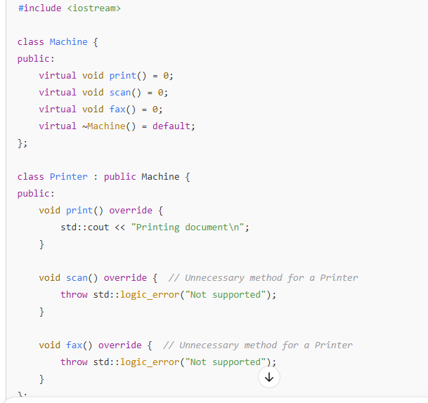
  - Here the Machine interface forces the printer class to implement scan & fax functions eventhough its irrelevant to printer
    - Note:-If pure virtual function in an abstract class is not overriden in the inherited class.The inherited class will also become abstract (i.e we wont be able to instantiate Printer class)
  - When a new function is added to the Machine class all the derived classes are forced to implement it causing unnecessary changes .
  - Correct approach using ISP (Good Design)
    - Instead of one large interface,we can create separate ,smaller interfaces.

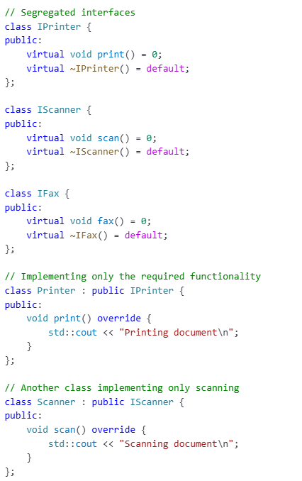

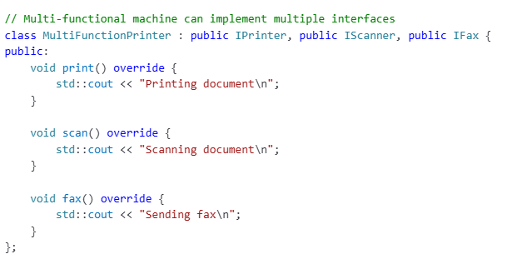

e.Dependency Inversion Principle
Tuesday, March 4, 2025
4:39 PM

  - Dependency Inversion Principle(DIP) in SOLID principles states that
    - High-level modules should not depend on Low-level modules.Both should depend on abstraction.
    - Abstraction should not depend on details ,Instead details should depend on abstractions.
  - It ensures that modules depends on abstraction or interface classes rather than concrete implementation.
VIOLATION OF DIP
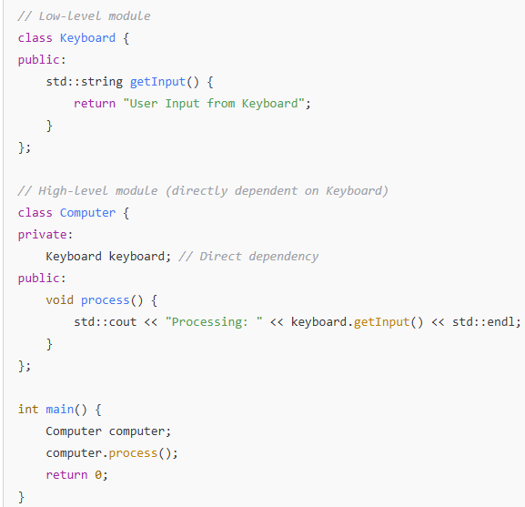
  - Here the class Computer(High level Module ) is directly dependent on Keyboard(low level module )
  - If we want to use mouse as input instead of keyboard,we must modify the Computer class.

Applying Dependency Inversion Principle
  - Introduce an abstract Interface(IInputDevice).
  - Make Keyboard Implement IInputDevice.
  - Inject the dependency into Computer.

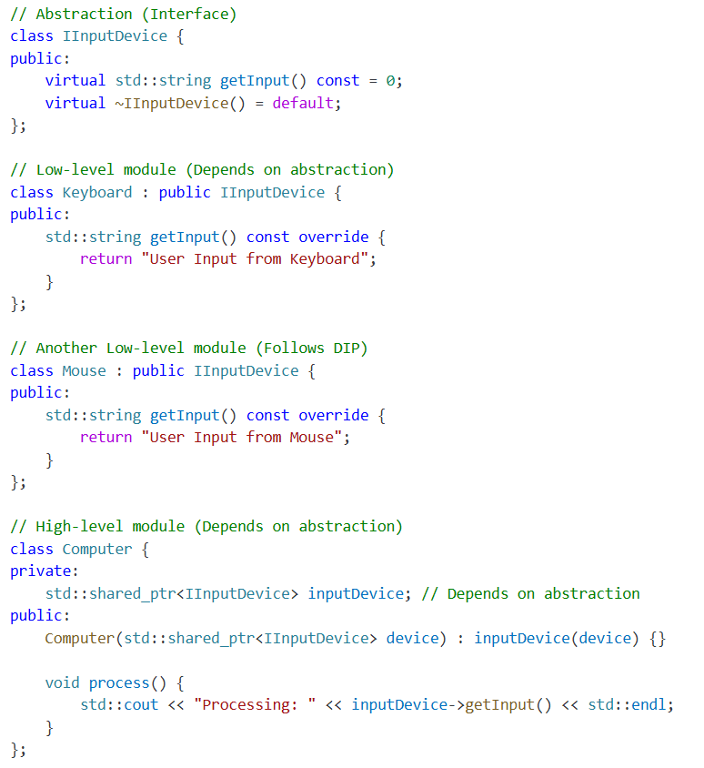

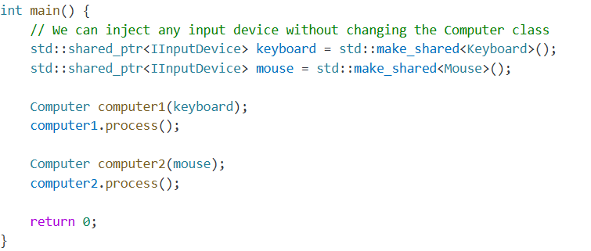
  - Loose Coupling: Computer no longer depends on Keyboard or Mouse directly.
  - Easier to Extend: We can add more input devices (like a touchscreen) without modifying Computer.

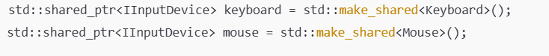
  - keyboard is a shared pointer object of type IInputDevice that points to Keyboard instance
  - Mouse is a shared pointer object of type IInputDevice that points to Mouse instance

I. Diamond Design Pattern
Wednesday, May 28, 2025
1:44 PM
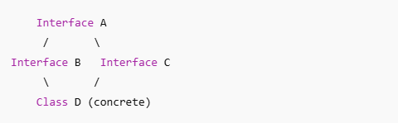
- There is a base class Abstraction (A)
- There are 2 intermediatory abstractions or Implementations(B and C) that derives from A .
- The concrete class (D) derives from both B and C
🔐 Scenario: Secure Event Logging in a Telematics Control Unit (TCU)
You are building a logging system for a Telematics Control Unit (TCU) that needs to capture and securely handle cybersecurity-relevant events, such as:
- Failed authentication attempts
- Secure access (UDS 0x27) violations
- Suspicious CAN traffic
- Tampering attempts (debug port access)
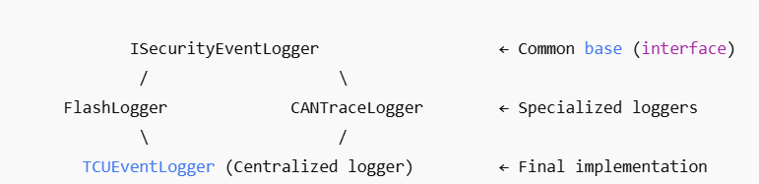

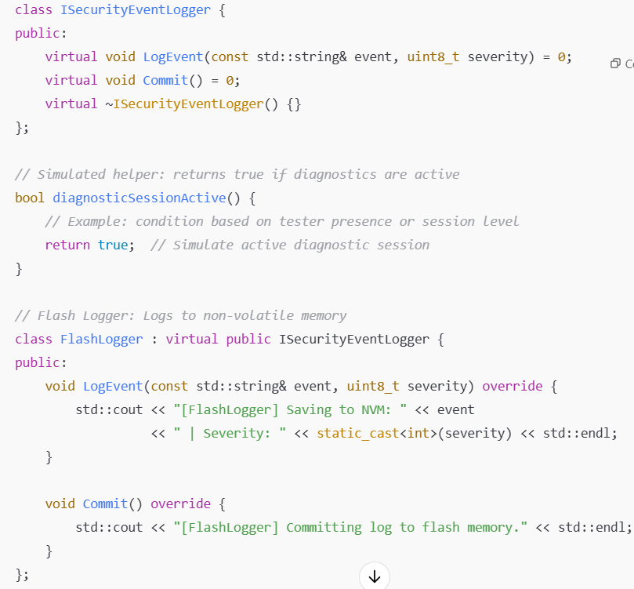
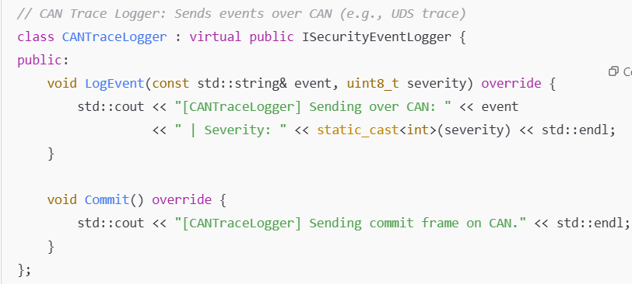
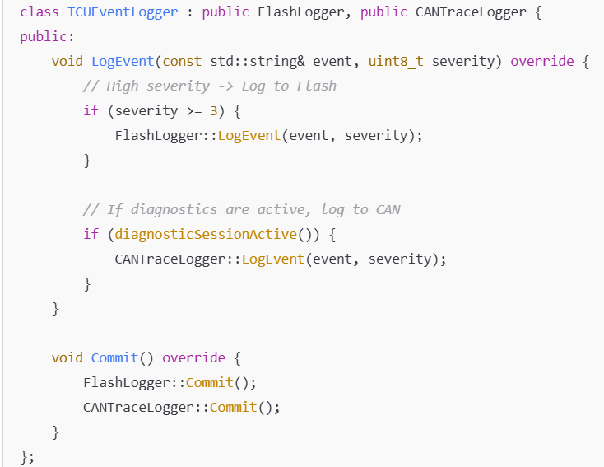
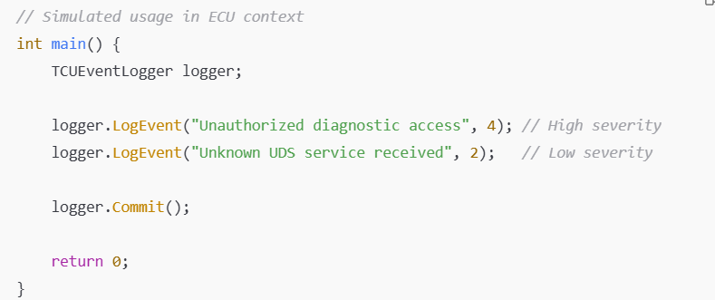

1. ISecurityEventLogger:
Defines the standard logging API every security event logger must follow.
2. FlashLogger:
- Implements logging to non-volatile memory (EEPROM or flash).
- Used when the event must survive power cycles (e.g., tamper attempts).
- Fulfills requirements of forensic retention.
3. CANTraceLogger:
- Implements sending structured events via a diagnostic channel (e.g., over UDS on CAN or DoIP).
- Used for real-time monitoring by external diagnostic tools or during development/validation.
4. TCUEventLogger:
- Inherits from both FlashLogger and CANTraceLogger.
- Acts as a centralized component that decides:
  - If the event is critical, store it in flash.
  - If live diagnostics are active, also forward it over CAN
📌 Key Takeaways:
- FlashLogger handles persistence.
- CANTraceLogger handles real-time diagnostics.
- TCUEventLogger makes smart decisions based on severity and context.
- Implements the Diamond Design Pattern cleanly with virtual inheritance to avoid ambiguity.
Let me know if you’d like this refactored into an AUTOSAR-style component, have this integrated with UDS services (0x27, 0x19), or simulated in a unit-testable module.

II. Singleton Pattern
Monday, March 3, 2025
7:30 PM
- A singleton is used to ensure that a class has only one instance and provides a global point of access to that object

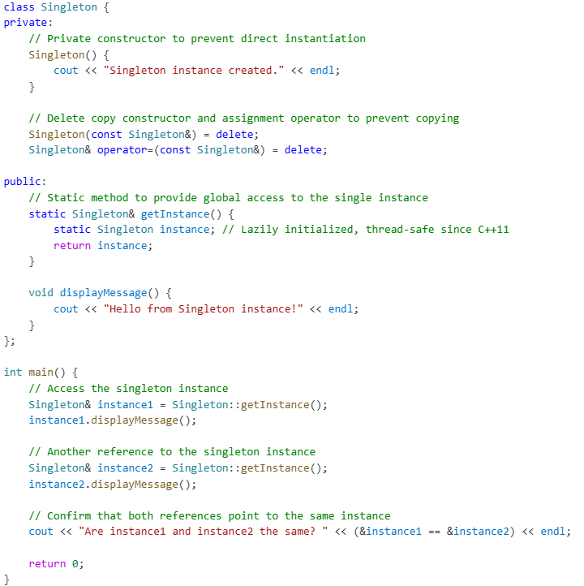

Keys Elements in a Singleton Class
- Private Constructor :-
  - Prevents direct creation of instances
- Static Instance :-
  - Ensures only a single instance is shared globally
- Deleted Copy & Assignment Operator :
  - Prevents copying /assigning the Singleton Instance .

Key Features of Singleton Pattern
- Single Instance: Only one object of the class exists during the lifetime of the application.
- Global Access: Provides a global point of access to the instance.
- Lazy Initialization: The instance is created only when it is accessed for the first time.

III.Observer Design Pattern
Thursday, July 17, 2025
1:32 PM
- Observer design pattern is a behavorial pattern that allows one object (called subject) to notify a list of dependent objects(Observers) automatically when its state changes .
Key Concepts
- Subject: The object being observed. It maintains a list of observers and notifies them of any state changes.
- Observer: An interface or abstract class that defines the update() method, which gets called when the subject changes.
- Loose Coupling: The subject and observers are loosely coupled — the subject doesn’t need to know the details of its observers.
Real-world Analogy
Think of a YouTube channel (Subject) and its Subscribers (Observers). When the channel uploads a new video, all subscribers get notified.
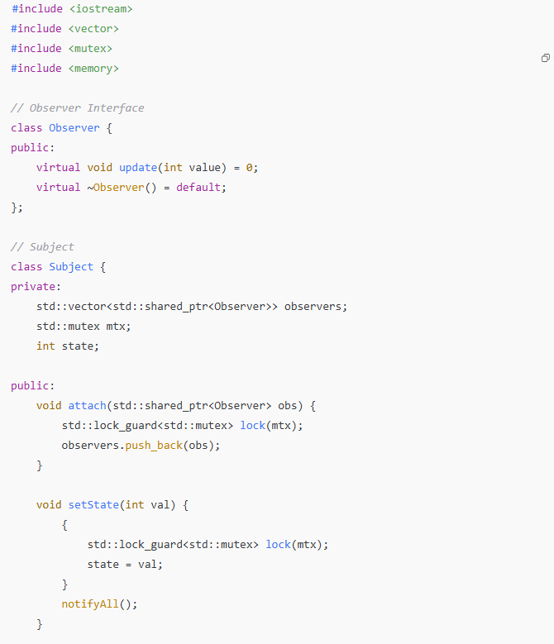

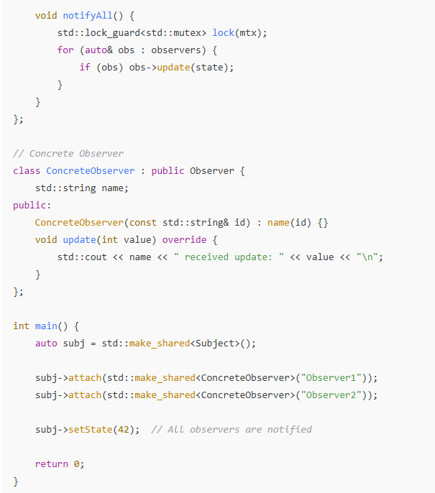

📝 Summary:
- Observer Pattern decouples subject and observers, promoting loose coupling.
- Helps in event-driven or real-time update scenarios.
- Adding thread-safety ensures the pattern works reliably in multithreaded environments.

IV.Factory Pattern
Tuesday, April 22, 2025
1:41 PM
  - Factory pattern is a creational design pattern that provides a way to create objects without exposing the instantitation logic to the client .
  - The object creation is done via common interface ,and client code depends only on this interface.
🧪 Example: Sensor Interface in Automotive
  - We have different sensors in a car SpeedSensor, TemperatureSensor and we want to use them via a common interface.
  - Step 1 :- Create an interface class(sensor.hpp)
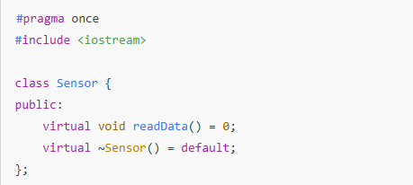
  - Step 2:- Concrete Implementations (SpeedSensor,TempSensor) inheriting from interface class
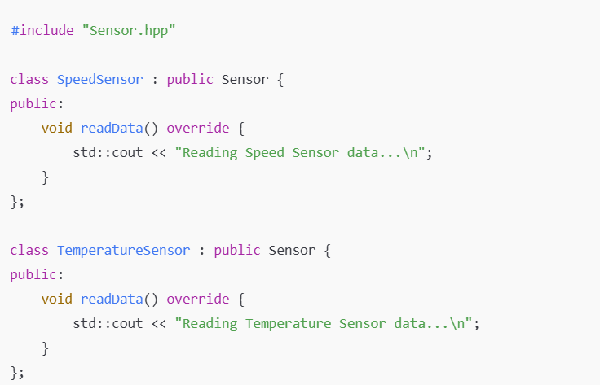
  - Step 3:- Factory Class
  - Factory class is responsible for creating instances of derived sensor classes.
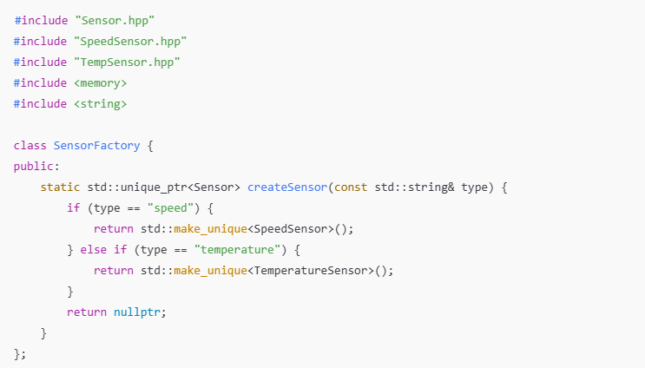
  - Factory class here is a static only class, as no instance needs to be created .
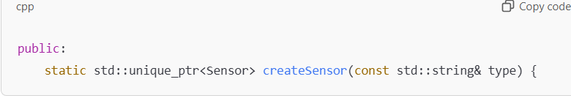
  - createSensor is a static method, so you don’t need to instantiate SensorFactory to call it.
  - It returns a std::unique_ptr<Sensor>
    - Caller recieves exclusive ownership of the object .
🔁 Decision Logic (Factory Behavior)
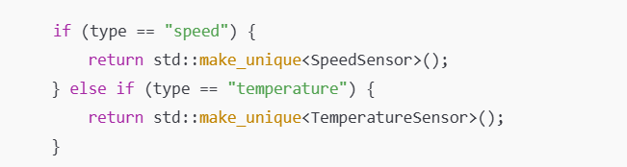
  - Based on the type ("speed" or "temperature"),the method decides which sensor class to instantiate.

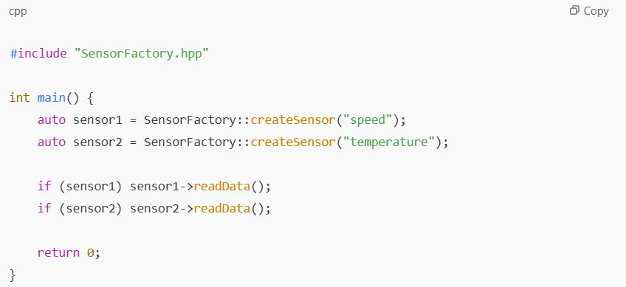

📌 Summary:
  - Factory Pattern abstracts object creation, useful in variant management (like multiple sensor or ECU implementations).
  - std::unique_ptr simplifies memory management and enforces safe, single ownership — crucial in embedded and safety-critical software.

V.Producer Consumer Pattern
Wednesday, July 16, 2025
6:30 PM
  - Producer consumer pattern is a classic concurrancy pattern where
    - Producer thread generates data and store it in the shared queue/buffer.
    - Consumer thread removes and process data from the shared queue
This pattern ensures:
  - Safe access to shared resources.
  - Efficient communication between threads.
  - Decoupling of data production and consumption rates.
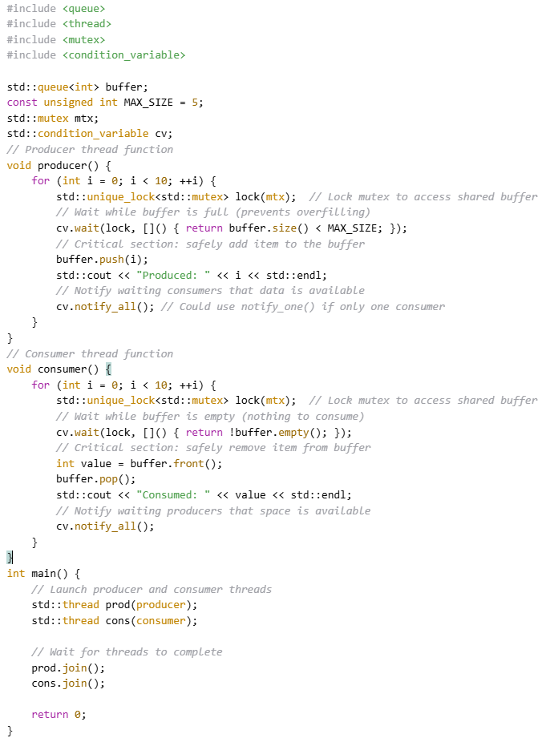

🔍 4. Explanation – Line-by-Line Insight
🔸 Shared Resources:

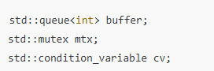
  - buffer is shared between producer and consumer.
  - mtx ensures only one thread modifies it at a time.
  - cv helps threads wait/signal based on buffer state.

🔸 Waiting with cv.wait(lock, condition):

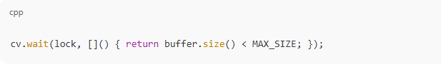
  - Releases lock while waiting.
  - Reactivates when cv.notify_all() is called.
  - Reacquires lock and checks condition again.

🔸 Signaling with cv.notify_all():

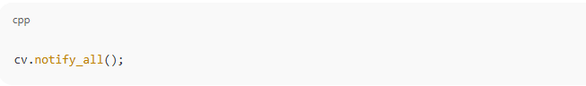

  - Wakes all threads waiting on cv.
  - Not all will proceed immediately — they’ll recheck their condition after acquiring lock.

